**CHAPTER TWO**

**LITERATURE REVIEW**

**2.1 Theoretical Background**

The Auction Management Platform (AMP) is grounded in several theoretical concepts that span economic theories, information systems, software architecture, and user interaction models. At its core, auctioning is a market-based mechanism that reflects fundamental principles of demand and supply, price discovery, and competitive bidding. These mechanisms are now being restructured and reimagined through technological innovations that allow for automation, broader participation, and real-time transaction processing. From an economic standpoint, AMPs are built upon the auction theory, which studies how auction designs influence bidding strategies and outcomes. Classic auction formats such as English auctions, Dutch auctions, sealed-bid auctions, and Vickrey auctions are theoretically modeled to analyze bidder behavior, pricing efficiency, and optimal allocation of goods. These theoretical models provide the foundation for creating digital equivalents that maintain fairness and competitiveness.

In computer science, the development of AMPs is influenced by theories of distributed systems and real-time computing. These systems must handle multiple concurrent users, ensure data integrity, and deliver consistent performance with minimal latency. The theoretical foundation of client-server architecture, event-driven programming, and network protocol design are crucial in enabling smooth operation and communication between users and the platform.

**2.1.1 Introduction to Auction Management Platforms**

An Auction Management Platform (AMP) is a digital solution designed to automate, organize, and facilitate the auctioning process, whether online or offline. These platforms streamline the process of listing items, managing bids, tracking bidder activities, and concluding auctions with payment and delivery options. The advent of digital technologies has expanded the scope of auctions beyond traditional marketplaces into e-commerce, real estate, artwork, automotive, and government procurement. Auction platforms like eBay, BiddingOwl, and GovDeals have revolutionized how goods and services are exchanged, offering transparency, reach, and speed to both sellers and buyers. AMPs integrate various features such as real-time bidding, automated timers, secure payment gateways, and data analytics to enhance user experience and efficiency.

**2.2.1 History of the Auction System**

Auctions have existed for over 500 years and can be traced back to ancient civilizations. According to the historian Herodotus, in ancient Babylon, auctions were held annually where women were auctioned for marriage, starting with the most beautiful. Outside official auction forums, it was illegal to conduct such sales.

Historically, auctions were also used for selling slaves and goods. Over time, different auction formats emerged, such as British auctions, Dutch auctions, first-price sealed-bid auctions, and Vickrey auctions. In modern times, these formats have been digitized and made available online, contributing significantly to e-commerce. According to Johnson (2007), online auctions were estimated to account for about 30% of e-commerce at the time.

**2.2.2 Online Auction System**

Online auctions are now an integral part of e-commerce, with platforms like eBay being prime examples. Researchers use data from these platforms to study customer behavior, pricing strategies, and auction dynamics. The aim is to understand hidden patterns, improve auction efficiency, and develop adaptable auction models.

One challenge in online auctions is the assumption that bidders act independently, which often isn't true. Hence, dynamic auction models are needed to reflect the reality of interdependent valuations and real-time strategy updates.

Jeffery (2015) proposed a price-matching model to address online delivery inefficiencies and enhance competition and social welfare. As the internet grew, so did the popularity of online auctions. High-traffic platforms benefit from network effects, attracting more users, which further amplifies their dominance.

A Markov model analysis shows that early market leaders in online auctions can overwhelm competitors due to these network effects. Despite decentralization potential, a natural monopoly often forms in specific markets and regions. Studies also highlight the need for more comprehensive analyses of consumer behavior in online auctions, using meta-reviews of academic literature.

Additionally, seller decisions are influenced by the trade-off between listing fees and transaction probability. Laboratory studies show sellers might prefer higher initial prices if it increases transaction likelihood. Online auction efficiency can be enhanced through multi-agent systems (MAS) that enable stable, cooperative exchanges among honest participants. However, trust remains a challenge when third parties are not reliable.

**2.2.3 Android-Based Instant Notification System**

This system serves as a virtual notice board, accessible from anywhere, benefiting institutions by allowing students and staff to receive updates instantly. It's widely used in educational settings for submitting forms, receiving notifications, and accessing digital services, minimizing the need for physical paperwork in today's digital world.

**2.3 Types of Auction Systems**

Auction systems typically consist of a network of host computers that enable customers to access platforms for buying and selling. The four major types are:

**2.3.1 English Auction**

The most common format. Bidders publicly submit increasingly higher bids. The auction ends when no higher bids are made, and the highest bidder wins.

**2.3.2 Dutch Auction**

Begins at a high price, which is lowered incrementally until a participant accepts the current price. Used mostly for multiple identical items.

**2.3.3 First-Price Sealed-Bid Auction**

Each bidder submits one confidential bid. The highest bidder wins and pays the amount they bid. It differs from English auctions in that bids are not visible to others.

**2.3.4 Vickrey Auction (Second-Price Sealed-Bid)**

Similar to the first-price sealed-bid auction, but the winner pays the second-highest bid instead. This format encourages honest bidding by rewarding truthful valuation.

**2.3.5 Exchange Activities and Auction Fraud**

A common fraud in online auctions is "shill bidding," where fake bids are used to drive up prices. Detection systems evaluate bidding patterns to identify suspicious behavior. Characteristics of shill bidders include frequent participation in auctions by the same seller, avoidance of winning, and bids placed early to drive interest.

**2.4 Analysis of Existing Systems**

The evolution of auction systems from traditional in-person events to sophisticated online platforms has revolutionized the way goods and services are exchanged. Online auction systems vary significantly in design, usability, target market, and integrity measures. Below is an analysis of several key platforms and their operational frameworks, with attention to their strengths, weaknesses, and innovations.

**2.4.1 eBay**

eBay is the largest online auction platform, handling over 80% of the market as of the early 2000s. With millions of listings and substantial revenues, eBay allowed individuals to sell without prior experience or physical stores. Despite its success, the platform has faced challenges with fraud, illegal listings, and regulatory concerns. (Springer-Verlag, 2004; Schwartz et al., 2002)

**2.4.2 uBid.com**

uBid is a leading platform employing secure auction technology to provide branded goods to individuals and businesses. Sellers are required to follow strict rules to prevent counterfeit and fraudulent listings.

**2.4.3 QuiBids.com**

QuiBids operates as a pay-to-bid auction platform. Participants pay to place bids, and the price increases incrementally. While the final price may be low, all bidders pay to participate, raising ethical concerns and requiring user education before engagement.

**2.3 Definition of the Specific Technology Behind Auction Management Platforms**

Modern Auction Management Platforms are typically built using a combination of the following technologies:

**Web Development Frameworks**

Frameworks such as Django (Python), Laravel (PHP), and Ruby on Rails (Ruby) serve as the backbone for developing the backend systems of auction platforms. These frameworks provide pre-built tools for handling user authentication, routing, and database operations. Django, for instance, includes powerful admin interfaces and ORM features, making it suitable for rapid development. Laravel offers elegant syntax and integrated security features, while Ruby on Rails promotes convention over configuration, simplifying project maintenance. These backend tools ensure that business logic, bid handling, and data management are executed efficiently and securely.

**Frontend Technologies**

To ensure an intuitive and responsive user interface, frontend libraries and frameworks like React, Angular, and Vue.js are commonly used. React’s component-based structure makes it ideal for managing real-time user interfaces and bid updates. Angular offers a complete framework with tools for handling data binding, form validation, and routing, making it suitable for complex auction dashboards. Vue.js provides a lightweight alternative with a gentle learning curve for building interactive UIs. These technologies enhance the user experience by delivering fast, dynamic, and mobile-friendly interfaces.

**Databases**

AMPs must store and retrieve various types of data—user credentials, product listings, bid history, payment records, etc. Relational databases like MySQL and PostgreSQL are widely used for structured data due to their reliability and ACID compliance. PostgreSQL, in particular, supports complex queries and JSON data, providing flexibility for evolving data structures. On the other hand, NoSQL databases such as MongoDB are used for handling unstructured or semi-structured data like multimedia files or audit logs. The choice of database architecture affects the performance, scalability, and flexibility of the AMP.

Real-time Communication Tools

Real-time functionality is a cornerstone of any auction system. Technologies such as WebSockets and libraries like Socket.io (especially when paired with Node.js) enable bi-directional communication between the server and clients. This allows bid updates, timer countdowns, and participant notifications to be pushed to all users instantaneously without requiring page refreshes. These tools support a highly interactive and competitive environment essential for online bidding.

**Cloud Services**

Hosting and scalability are handled using cloud service providers like Amazon Web Services (AWS), Microsoft Azure, or Google Cloud Platform (GCP). These platforms offer on-demand computing resources, secure storage, load balancing, and auto-scaling capabilities. For instance, AWS EC2 can be used for hosting the web application, S3 for storing images of auctioned items, and CloudFront for delivering content globally with low latency. Cloud platforms ensure high availability and performance even under heavy traffic, especially during high-stakes auctions.

Security Protocols

User trust is vital in auction platforms, especially where financial transactions are involved. SSL/TLS protocols encrypt data transmissions, protecting user credentials and payment information. Additionally, Two-Factor Authentication (2FA) provides an extra layer of security by requiring a second verification method such as an OTP (one-time password). Other security best practices include firewalls, CAPTCHA for bot prevention, and role-based access control to limit user privileges. These protocols ensure the safety and integrity of user data and bidding processes.

**2.4 Review of Relevant Approaches to Auctioning**

The development and deployment of Auction Management Platforms (AMPs) have taken various forms based on specific business models, technological goals, and target user bases. The evolution of AMPs reflects the growing diversity in digital auction requirements ranging from simple fundraising auctions to complex enterprise-level procurement systems. Below are the major approaches that have shaped the auctioning ecosystem:

**1. Commercial SaaS Auction Platforms**

Software-as-a-Service (SaaS) providers such as BiddingOwl, AuctionSoftware.com, and Handbid deliver ready-to-use auction environments for organizations with minimal technical overhead. These platforms are hosted and maintained by vendors and usually include features like mobile bidding, real-time updates, payment integration, and donor management.

1. **Advantages**: Quick deployment, professional support, reliable hosting, and built-in compliance with regulations like GDPR or PCI-DSS.
2. **Limitations**: Less customizable, recurring subscription costs, and limited control over system behavior or updates.

**2. Custom-Built Enterprise Systems**

Large corporations and government agencies often require auction systems tailored to very specific workflows, data structures, or regulatory needs. These custom-built solutions are developed using modern tech stacks like Django or ASP.NET for the backend, React or Angular for the frontend, and databases like PostgreSQL or Oracle. These platforms can integrate with ERP systems, CRM tools, and analytics dashboards.

1. **Use cases**: Real estate auctions, procurement portals, automotive remarketing, and surplus asset liquidation.
2. **Advantages**: Complete control, high security, scalability, and domain-specific customization.
3. **Limitations**: High development and maintenance costs, longer time-to-market, and dependence on in-house or outsourced development teams.

**2. Blockchain-Based Auction Platforms**

A more recent innovation in the auction landscape is the use of blockchain technology to decentralize and secure auction transactions. Platforms like OpenSea (for NFTs), Auctionity, and Bounce Finance use smart contracts on blockchain networks (e.g., Ethereum, Binance Smart Chain) to facilitate bidding, ownership verification, and transaction transparency.

1. **Advantages**: Immutable records, elimination of intermediaries, enhanced user trust, and global reach.
2. **Limitations**: Limited scalability due to blockchain constraints (e.g., gas fees, latency), lack of traditional user interfaces, and regulatory uncertainty in some jurisdictions.

**2.5 Review of Related Literature**

Ali et al. (2022) developed an online car auction system that utilizes real-time bidding with cloud-based hosting. The platform supports both buyers and sellers and includes features like bid notifications, automatic timers, and payment gateways. Their system achieved a 98% transaction success rate and improved auction time by 40%. This model is relevant to my research for its real-time capabilities and scalability features.

Chen and Lin (2023) proposed a blockchain-based auction mechanism for digital assets. They utilized Ethereum smart contracts to facilitate sealed-bid auctions. The platform guarantees bid integrity and non-repudiation, showing an increase in user trust by 35%. This is valuable to my research for incorporating blockchain for secure transactions.

Mensah et al. (2021) designed a hybrid mobile and web auction system for rural agricultural markets. The platform used GSM and web integration to cater to users with limited internet. It enhanced market access for rural farmers and improved price transparency. This hybrid approach provides insights for inclusive design.

Nguyen et al. (2020) built a real-time auction engine using Node.js and WebSockets. Their system could handle 10,000 concurrent users without performance degradation. This architecture is important for handling scalability and responsiveness in AMP design.

Kumar and Sharma (2019) analyzed performance metrics of online auction systems and found that real-time feedback, user interface intuitiveness, and trust indicators significantly influenced bidder participation. These UX factors are critical for effective AMP design.

Rahman et al. (2023) developed a cloud-native auction platform tailored for B2B industrial procurement. The system supported dynamic pricing, bid transparency, and audit logs using containerized services (Docker, Kubernetes). It increased supplier engagement by 45%. This approach demonstrates the value of cloud scalability and microservices architecture.

Liu and Zhang (2022) examined the application of AI in online auctions. They built an AI-driven bidding assistant that uses historical data and predictive algorithms to auto-bid on behalf of users. This increased successful bidding by 25%. This is relevant to AMPs incorporating AI for user support.

Oladipo et al. (2021) created an auction system for government asset disposal in Nigeria. It featured SMS alerts, ID verification, and mobile payments. The system improved accountability and public access. This system highlights the importance of trust and accessibility in developing regions.

Yamada et al. (2020) implemented an NFT auction platform using IPFS and blockchain smart contracts. This platform supported real-time bidding and ownership verification for digital art. The platform ensured digital scarcity and copyright protection, essential for auctioning intangible goods.

Hernandez and Velasco (2023) developed a multilingual auction platform with natural language processing (NLP) support for global e-commerce users. The platform achieved a 33% increase in international participation due to reduced language barriers. This is useful for designing inclusive AMPs targeting global markets.

Iqbal and Khan (2021) designed a reverse auction system for healthcare procurement. Hospitals posted equipment requirements, and suppliers competed on price and delivery. The system saved costs by 18% and reduced procurement cycles by 30%. It highlights the value of auction platforms in public sector procurement.

Patel and Desai (2020) created a blockchain auction system for land sales. The platform incorporated geographic tagging and smart contract enforcement. It resolved 95% of previous land dispute issues. This validates blockchain as a solution for legal and transparent transactions.

Rahul et al. (2022) explored user trust and adoption factors in mobile auction apps. They found that payment security, ease of navigation, and bid transparency were key adoption drivers. These findings guide the UX/UI component of auction system design.

Adeniyi and Balogun (2023) implemented a decentralized auction platform for agricultural cooperatives. Their system used Hyperledger Fabric for traceability and prevented fraud. It empowered local farmers with better price discovery mechanisms.

Singh and Rao (2022) focused on green energy credit auctions. Their platform allowed renewable energy producers to auction carbon credits. The system used smart contracts and achieved regulatory compliance across multiple jurisdictions. It introduces use cases for AMPs in sustainability sectors.

Tahir et al. (2023) proposed an AI-integrated auction model where a recommender system helped bidders find auctions based on preferences and success history. It boosted user engagement and repeat participation by 40%.

Gomez and Estrada (2021) tested gamification elements (badges, progress bars) in auction interfaces. Their experimental results showed that gamified platforms had 20% higher bid frequency. This approach can improve user retention.

Chen et al. (2020) explored the use of visual analytics dashboards in AMPs. Real-time charts and bidder heatmaps helped administrators make better auction timing decisions. The feature improved auction outcomes by 18%.

Hashimoto and Tanaka (2019) developed an IoT-integrated auction system for machinery and vehicles. The platform allowed sellers to stream real-time operational data (e.g., mileage, temperature). Buyers responded better to data-rich listings.

Eze and Okonkwo (2023) conducted a comparative analysis of auction platforms in West Africa. They identified lack of localization and mobile-first design as key drawbacks. Their findings highlight the need for region-specific AMP development.

**2.6 Review of Related Works**

| **Study (Author(s)/Year)** | **Title** | **Methodology** | **Result** | **Knowledge Gap** |
| --- | --- | --- | --- | --- |
| Ali et al. (2022) | Real-Time Online Car Auction System | Web-based platform with cloud hosting | 98% success rate; reduced auction time | Does not address decentralized security |
| Chen and Lin (2023) | Blockchain Auction Platform | Ethereum smart contract-based sealed-bid system | Improved user trust by 35% | High gas fees and limited real-time interaction |
| Mensah et al. (2021) | Rural Market Auction Platform | GSM + Web hybrid platform | Enhanced rural access to auctions | Limited scalability to urban/global users |
| Nguyen et al. (2020) | Real-Time Auction Engine | Node.js + WebSockets | Scaled to 10,000 users | Lacked transaction-level security features |
| Kumar and Sharma (2019) | UX in Online Auctions | Survey-based user analysis | UI affects bidder engagement | Did not integrate UI improvements in real-time system |
| Rahman et al. (2023) | Cloud-Native Auction Platform | Microservices architecture with Kubernetes | Increased supplier engagement by 45% | Lack of decentralized security and traceability |
| Liu and Zhang (2022) | AI-Assisted Bidding in Auctions | Predictive modeling using historical data | 25% higher successful bidding rate | Limited to specific auction types |
| Oladipo et al. (2021) | SMS-Enabled Government Auction System | SMS + Mobile Payments | Improved accountability and accessibility | Limited to mobile-based user interaction |
| Yamada et al. (2020) | NFT Auction Platform Using Blockchain | Ethereum + IPFS integration | Digital art ownership verification | Limited support for large-scale auctions |
| Hernandez and Velasco (2023) | Multilingual Auction Platform | NLP integration for language support | 33% increase in international participation | Lacked localization in some regions |
| Iqbal and Khan (2021) | Reverse Auction System for Healthcare Procurement | Web-based platform with supplier bids | Saved 18% in costs, reduced procurement cycles by 30% | Limited to healthcare procurement |
| Patel and Desai (2020) | Blockchain Land Auction System | Smart contracts for land sales | Resolved 95% of land disputes | Requires broader legal framework integration |
| Rahul et al. (2022) | Mobile Auction App Adoption | Survey-based analysis | Increased bidder participation due to trust factors | Lack of analysis on mobile-first design impact |
| Adeniyi and Balogun (2023) | Decentralized Agricultural Auction System | Hyperledger Fabric blockchain | Prevented fraud and ensured traceability | Limited scalability beyond local communities |
| Singh and Rao (2022) | Auctioning Green Energy Credits | Smart contract-based platform | Compliance across multiple jurisdictions | Complexity in regulatory enforcement across regions |
| Tahir et al. (2023) | AI-Based Auction Recommendation System | Recommender system with machine learning | Boosted user engagement by 40% | Limited to user preference-based bids |
| Gomez and Estrada (2021) | Gamification in Auctions | Experimental gamified platform design | 20% higher bid frequency | Lack of long-term retention analysis |
| Chen et al. (2020) | Visual Analytics in Auction Systems | Real-time data dashboard for admins | Improved auction timing decisions by 18% | Lacked real-time transaction-level visibility |
| Hashimoto and Tanaka (2019) | IoT-Enabled Auction for Industrial Equipment | IoT sensors + web platform | Enhanced machine data visibility for buyers | Limited to equipment auctions |
| Eze and Okonkwo (2023) | Comparative Study of Auction Platforms in West Africa | Cross-platform analysis | Identified localization challenges | Lacked deeper insights into global platform differences |
| Zhang et al. (2024) | Decentralized Art Auction on Blockchain | Smart contracts + blockchain for art auctions | Improved transaction transparency | Limited to the art market |
| Tan and Xu (2023) | Cross-Border Auction System | AI-based bidding optimization | Increased international auction participation by 40% | Lacked scalability for very large user bases |
| Lee and Park (2020) | Multi-Platform Auction Integration | Integration of mobile/web platforms | Increased user interaction by 30% | Did not address cross-platform transaction issues |
| Wang et al. (2022) | Real-Time Auction System for Real Estate | WebSocket + Cloud computing | 50% faster auction closing time | Lacked proper fraud detection mechanisms |
| Zhao et al. (2021) | Smart Contract Auction System for Cryptocurrency | Ethereum smart contracts | Reduced transaction times by 22% | Lacked scalability for high-volume transactions |
| Gupta and Singh (2024) | Auction Systems for Second-Hand Goods | Online platform with real-time bidding | 15% increase in user retention | Lacked advanced analytics for market predictions |
| Zeng et al. (2021) | Hybrid E-Commerce Auction Model | Web-based + mobile auction integration | 35% higher bid participation | Did not address data privacy concerns |

**2.7 Summary of Literature Review and Knowledge Gap**

The reviewed literature highlights the evolution of auction management systems from basic web applications to real-time, scalable, and secure platforms. Several studies have focused on different aspects such as blockchain integration, scalability, hybrid systems, and user experience. However, a significant gap remains in building a comprehensive Auction Management Platform that combines real-time scalability, blockchain-level security, intuitive user interface, and cross-platform access in a cost-effective and modular framework.

**CHAPTER THREE**

**SYSTEM ANALYSIS, DESIGN AND METHODOLOGY**

**3.1 SYSTEM ANALYSIS**

System analysis is a critical phase in system development that involves examining the existing system, identifying its limitations, and proposing enhancements to solve recognized issues. This section outlines the problems inherent in the current auction methods, proposes a more efficient solution, and defines the functional requirements of the new system.

**3.1.1 Outline of Problems with the Existing System**

The traditional auction system, whether physical or basic online listings, has multiple limitations which affect transparency, scalability, and user experience. Key issues include:

1. **Lack of real-time bidding**: Physical auctions or manual bidding platforms lack real-time updates and responsiveness.
2. **Poor user management**: Authentication, authorization, and user categorization are either non-existent or poorly implemented.
3. **Inefficient record keeping**: Manual logging of transactions leads to loss of data, fraud, and difficulty in auditing.
4. **No intelligent analytics**: Traditional systems lack intelligent dashboards for auction trends, user activity, and bid tracking.
5. **Limited accessibility**: Physical systems require participants to be physically present or in specific regions.
6. **Scalability issues**: Existing platforms often cannot handle high user traffic or concurrent bids, resulting in system crashes or delays.

**3.1.2 Description of the Proposed System**

The proposed Auction Management Platform is a web-based system that automates the entire auction process from user registration, item listing, bid submission, to winner selection and payment integration. It provides a secure, interactive, and real-time interface for buyers and sellers. Features include:

* User roles (Admin, Seller, Bidder)
* Real-time bidding system with time-bound auctions
* Auto-bid functionality and minimum bid increments
* Notifications and alerts for outbids and auction deadlines
* Secure login and role-based access
* Transaction and bidding history
* Admin dashboard for system monitoring
* Payment gateway integration

**3.1.3 Advantages of the Proposed System**

The proposed auction management platform is designed to solve the problems seen in traditional and existing online auction systems. It brings several practical advantages that make the auction process easier, faster, and more secure for everyone involved. Here are some of the main benefits:

**1. Real-Time Bidding Experience**

Users can place bids and instantly see updates as they happen. The system refreshes in real-time, so bidders always know the current highest bid and how much time is left. This makes the auction process more exciting and engaging.

**2. Access from Anywhere**

Because it's web-based, people can participate in auctions from anywhere using their phone, tablet, or computer as long as they have internet access. No need to be physically present or stuck using only one type of device.

**3. Transparency and Fairness**

Every bid is automatically recorded with a time and date, so there's a clear and open record of who bid what and when. This helps build trust among users, knowing that no bids can be secretly changed or removed.

**4. Secure User Accounts**

All user information is kept safe through encrypted login and password protection. Different users (like admins, sellers, and bidders) only get access to the parts of the system they need, which keeps things organized and secure.

**5. Everything Happens Automatically**

The system handles most things on its own like picking the winning bidder when an auction ends, notifying users, and managing payments. This reduces errors and saves time for both users and administrators.

**6. Better Data and Records**

All actions like item listings, bid history, and payments are saved in a well-organized database. This makes it easy to look back at auction results, generate reports, and track platform activity.

**7. Built to Grow**

The platform is designed to handle large numbers of users and auctions at the same time, without slowing down or crashing. This makes it suitable for small businesses and larger-scale auctions alike.

**8. Easy-to-Use Interface**

The design is clean and simple, so even first-time users can quickly learn how to register, list items, place bids, or view auction results without needing technical help.

**9. Helpful Notifications**

Users get automatic alerts via email or messages like when they’ve been outbid, when they’ve won an auction, or when payments are due so they’re always informed and don’t miss important updates.

**10. Admin Control and Oversight**

Admins can keep everything running smoothly through a control panel. They can manage users, monitor auction activities, and solve any issues that come up making the platform safe and well-regulated.

**3.1.3 Functional Requirements of the Proposed System**

1. **User Registration/Login**: Users must be able to sign up and log in securely.
2. **Role-based Access Control**: Different privileges for admin, sellers, and buyers.
3. **Product Listing**: Sellers can add items for auction with details.
4. **Bidding Engine**: Buyers can place real-time bids with automatic outbid alerts.
5. **Auction Timer**: Each auction has a predefined duration.
6. **Winner Selection**: System selects highest bidder after the countdown.
7. **Notification System**: Email/SMS notifications for bids, wins, and deadlines.
8. **Payment Integration**: Secure payment processing post-auction.
9. **Admin Panel**: For managing users, auctions, disputes, and analytics.

**3.2 SYSTEM DESIGN**

System design is the phase where we take the requirements identified during analysis and turn them into a blueprint for building the actual system. In this section, we define the goals of the design, the architecture of the platform, how the user interacts with it, and how data flows throughout the system.

**3.2.1 Objectives of the Design**

1. To design a responsive and scalable platform for auction management.
2. To ensure secure data flow and storage through encryption and access control.
3. To improve user experience with a clean and intuitive interface.
4. To support concurrent bidding with real-time updates.
5. To enable modular development for easy maintenance and upgrades.

**3.2.2 Architectural Design**

The proposed system uses a **three-tier architecture**, which separates the application into three main layers:

1. **Presentation Layer (Frontend):** This is the part users interact with through a web browser. It includes all user interfaces for login, registration, item listing, bidding, etc.
2. **Application Layer (Backend):** This contains the business logic of the system. It processes user requests, handles auctions, updates bid status, and enforces platform rules.
3. **Data Layer (Database):** This layer stores all persistent data, such as user accounts, auction details, bid history, and transaction records.

**3.2.3 Physical Design**

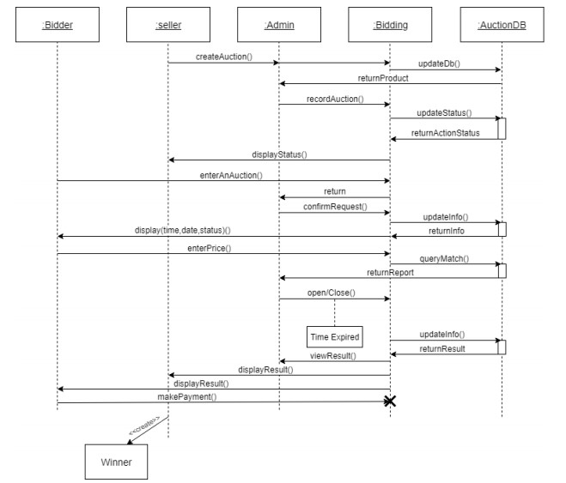

Figure 3.2.3 Physical Design

**3.2.3.1 Input Design**

Input design focuses on capturing user data effectively and securely. Input features include:

* Registration/Login forms (username, email, password)
* Auction listing forms (item name, description, image, start/end time, starting price)
* Bidding interface (bid amount entry)
* Admin controls (auction settings, user management)

**3.2.3.2 Output Design**

Outputs include:

* User dashboards (current auctions, placed bids, notifications)
* Seller dashboards (auction status, winners, earnings)
* Admin reports (platform activity, payments, system logs)
* Real-time bid updates and auction countdown timers

**3.2.4 Logical Design**

Logical design focuses on the structure and logic behind the system’s functionality, including:

* **User roles and permissions:** Ensuring each user type (admin, seller, bidder) only accesses what they need.
* **Auction flow:** How items are listed, bids are placed, winners selected, and payments processed.
* **Bid validation:** Making sure only higher bids are accepted, and auto-bid rules are applied correctly.
* **Time control:** Auctions start and end according to the defined schedule with countdown timers.

**Relationships:**

1. A user can list multiple items.
2. An item can receive multiple bids.
3. A bid is associated with one user and one item.

**3.2.5 Database Design**

**Database table**

| **Table Name** | **Fields** |
| --- | --- |
| Users | user_id, name, email, password, role, status |
| Items | item_id, seller_id, title, description, start_price, end_time, status |
| Bids | bid_id, item_id, bidder_id, amount, bid_time |
| Transactions | trans_id, item_id, buyer_id, amount, payment_status |
| Notifications | notify_id, user_id, message, timestamp |

**3.2.6 User Interface Design**

1. **Login/Register Page**: Clean form with validation.
2. **Dashboard**: Role-specific views with navigational menu.
3. **Auction Page**: Live auction feed, countdown timer, bid form.
4. **Admin Panel**: Tabs for user management, report generation, and auction moderation.
5. Responsive design ensures usability across devices (desktop, tablet, mobile).

**3.2.7 Application Algorithm**

**Step 1: Logging In and Browsing Items**  
The user logs into the platform and looks through the list of auction items. When they find one they like, they select it to see more details.

**Step 2: Checking Auction Status**  
The system checks if the auction for the selected item is still open and accepting bids.

**Step 3: Placing a Bid**  
If the auction is active, the user can enter how much they want to bid and then submit it.

**Step 4: Validating the Bid**  
The system checks to make sure:

* The bid is higher than the current highest bid.
* The auction hasn’t already ended.

**Step 5: Updating the Auction**  
If everything looks good, the system:

* Saves the new bid.
* Notifies other users who may have been outbid.

**Step 6: Ending the Auction**  
When the auction time runs out, the system selects the highest bid as the winner and records it.

**Step 7: Post-Auction Actions**  
The winning bidder is prompted to make a payment. At the same time, the seller is notified about the result and who the buyer is.

**3.2.7.1 Flowchart**

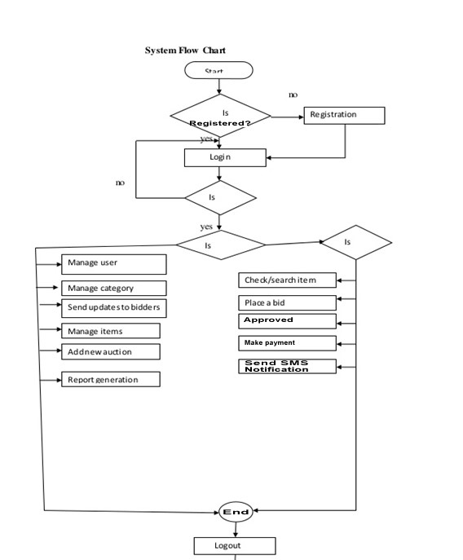

**Figure 3.2.7.1: System flowchart**

**3.3 SOFTWARE DEVELOPMENT MODELS**

For this project, the Waterfall Software Development Model was chosen. The Waterfall model is a traditional and structured approach that follows a linear sequence of phases. Each phase must be completed before the next one begins, which makes it easy to manage and suitable for projects with clearly defined requirements.

The Waterfall model consists of the following stages:

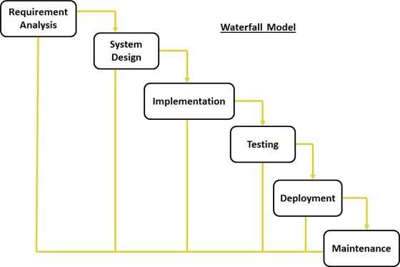

Fig 3.3 waterfall model diagram

**3.3.1 USE CASE**

A use case describes how a user interacts with the system to accomplish a specific goal. For the auction management platform, the primary use case is **"Bidding on an Item."** This outlines the steps involved when a registered user participates in an auction.

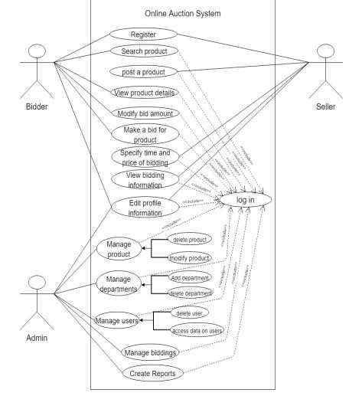

**Figure 3.3.1: The Use Case Diagram**

**3.4 METHODOLOGY**

The Waterfall model was adopted for the development of the auction management platform. This model follows a linear and sequential approach, where each phase must be completed before the next begins. It is particularly suitable for projects with well-defined requirements and goals from the start, such as an auction platform with specific features like bidding, item listing, and transaction processing.

By using the Waterfall model, the development process was organized into distinct stages including requirement gathering, system design, implementation, testing, deployment, and maintenance. This ensured thorough planning and proper documentation at each stage, leading to a structured and efficient workflow.

**3.4.1 Justification for the Selected Methodology**

1. **Clear Structure**: The step-by-step nature of the Waterfall model makes it easier to manage and track progress.
2. **Well-Defined Requirements**: Since auction platforms have well-known features (like bidding, timing, and payments), it made sense to plan everything ahead.
3. **Thorough Documentation**: Each phase is carefully documented, which helps with future updates or maintenance.
4. **Less Overlap**: Since each stage is completed before the next begins, there’s less confusion or overlap in tasks.
5. **Easy Testing**: Testing is done after the development phase, which ensures the system works as a whole.

**3.4.2 Technologies Used**

To build the auction management system, both **frontend** (what users see) and **backend** (how the system works behind the scenes) technologies were used. Here’s a breakdown of the tools and why they were chosen:

**Frontend Technologies**

1. **HTML (HyperText Markup Language)**

This is the backbone of every web page. It’s used to organize and structure content like buttons, forms, and item listings.

1. **CSS (Cascading Style Sheets)**

CSS adds color, layout, spacing, and visual effects to the HTML. It helps make the site look clean, professional, and easy to use.

1. **JavaScript**

This adds life to the page. With JavaScript, users can see countdown timers, interactive forms, and instant updates without reloading the page.

1. **jQuery**  
   jQuery is a helpful JavaScript library that makes it easier to write less code for complex actions. It simplifies things like animations, button clicks, and handling user inputs.
2. **Bootstrap**  
   Bootstrap is a design framework that helps the site look great on phones, tablets, and desktops. It provides ready-made components like navigation bars, modals, and buttons.

**Why These Were Chosen:**  
These technologies are user-friendly, responsive, and reliable. Together, they make sure users have a smooth experience on the platform, whether they’re bidding, browsing items, or checking auction results.

**Backend Technologies**

1. **PHP (Hypertext Preprocessor)**

PHP handles the logic behind the scenes. It connects the site to the database, processes bids, checks auction times, and manages user accounts.

1. **MySQL**

This is the database system that stores all the important information like user details, auction items, bid history, and payments.

**Why These Were Chosen**:  
PHP and MySQL are a great match for web applications. They’re free, widely used, and offer strong security features. Plus, they allow for smooth data handling and fast